<https://docs.google.com/forms/d/e/1FAIpQLScOYFEvJQ8fn9i_g58dNHLDVBqescy-cOxunROHvXgU105ZLQ/viewform?usp=sharing>

**Roll No: 2022_mc_58**

----------------------(Assesment2) ---------------------------

Part A

Algorithm:-

function dy= fun(t,y)

f=5;

m1=1;

m2=4;

k1=4;

k2=5;

k3=0;

fv1=3;

fv2=3;

fv3=2;

dy(1)=y(2);

dy(3)=y(4);

dy(2)=1/m1*(f-(k1+k2)*y(1)-(fv1+fv3)*y(2)+fv3*y(4)+k2*y(3));

dy(4)=1/m2*(-(fv2+fv3)*y(4)-(k2+k3)*y(3)+k2*y(1)+fv3*y(2));

dy=dy';

end

clc;

TR = [0 10];

X0 = [0;0;0;0]; %intial condition zero

[t,y]=ode45(@fun,TR,X0);

x1=y(:,1);

v1=y(:,2);

x2=y(:,3);

v2=y(:,4);

a1=gradient(v1);

a2=gradient(v2);

subplot(2,3,1)

plot(t,x1)

xlabel('time')

ylabel('Displacement-1')

subplot(2,3,2)

plot(t,v1)

xlabel('time')

ylabel('Velocity-1')

subplot(2,3,3)

plot(t,a1)

xlabel('time')

ylabel('Acceleration-1')

subplot(2,3,4)

plot(t,x2)

xlabel('time')

ylabel('Displacement-2')

subplot(2,3,5)

plot(t,v2)

xlabel('time')

ylabel('Velocity-2')

subplot(2,3,6)

plot(t,a2)

xlabel('time')

ylabel('Acceleration-2')

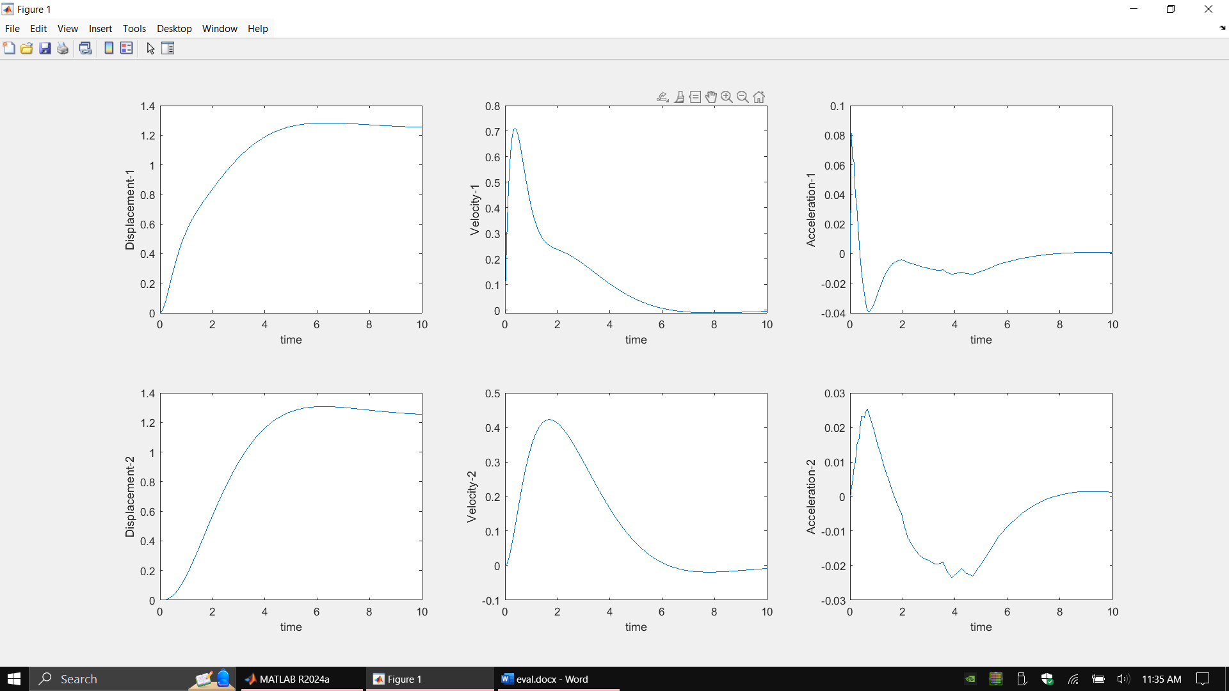

-----------------------(Assesment3) --------------------------

Part A

Algorithm:-

function dy= randFun2(t,y,T,J1,J2,J3,m,r,fv,k1,k2,d3)

dy(1)=y(2);

dy(3)=y(4);

dy(5)=y(6);

dy(2)=1/J1*(T - k1*y(1) + k1*y(3));

dy(4)=1/(J2+m*r*r)*(k1*y(1) - (d3+fv*r^2)*y(4) -(k1+k2*r^2)*y(3) + d3*y(6));

dy(6)=1/J3*(d3*(y(4)-y(6)));

dy=dy';

end

clc ;

% Transfer function (Theta_gear(s) / T(s))

num = [1]; % Numerator

den = [J1 0 k1]; % Denominator

% Create transfer function

sys_tf = tf(num, den)

% State-space matrices

A = [0 1 0 0 0 0;

-k1/J1 0 k1/J1 0 0 0;

0 0 0 1 0 0;

k1/(J2+m*r^2) 0 -(k1+k2*r^2)/(J2+m*r^2) -(fv*r^2+d3)/(J2+m*r^2) 0 d3/(J2+m*r^2);

0 0 0 0 0 1;

0 0 0 d3/J3 0 -d3/J3];

B = [0; 1/J1; 0; 0; 0; 0];

C = [1 0 0 0 0 0];

D = 0;

% Create the state-space system

sys_ss = ss(A, B, C, D);

%% Part A Variant Torque

clc;clear;

TR = [0 5];

X0 = [0;0;0;0;0;0];

k1=8;k2=5;fv=25;d3=2;T=5;m=15;J1=8;J2=10;J3=12;r=5;

for T=0:1:5

[t,y]= ode45(@(t,y)randFun(t,y,T,J1,J2,J3,m,r,fv,k1,k2,d3),TR,X0);

thGear=y(:,3);

omGear=y(:,4);

x=r*thGear;

v=r*omGear;

% Compute acceleration

a1 = gradient(v, t);

a2 = gradient(omGear, t);

subplot(2,3,4)

plot(t,thGear)

hold on

xlabel('time')

ylabel('theta-Gear')

subplot(2,3,5)

plot(t,omGear)

hold on

xlabel('time')

ylabel('Angular velocity-Gear')

subplot(2,3,1)

plot(t,x)

hold on

xlabel('time')

ylabel('displacement')

subplot(2,3,2)

plot(t,v)

hold on

xlabel('time')

ylabel('velocity')

subplot(2,3,3)

plot(t, a1)

hold on

xlabel('time')

ylabel('Acceleration-1')

subplot(2,3,6)

plot(t, a2)

hold on

xlabel('time')

ylabel('Angular acceleration-Gear')

end

for i=1:6

subplot(2,3,i);legend('1N Torque', '2N Torque', '3N Torque','4N Torque', '5N Torque')

end

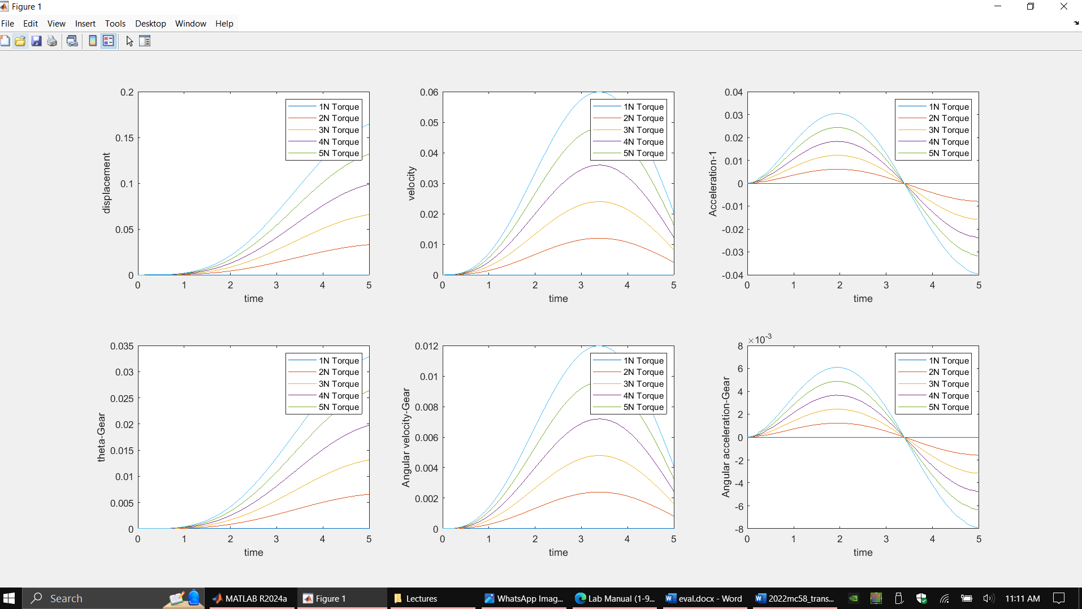

----------------------------------------------------(Changing Radius)---------------------------------------------------------------

clc;

clear;

TR = [0 50];

X0 = [0;0;0;0;0;0];

k1=8;k2=5;fv=25;d3=2;T=5;m=15;J1=8;J2=10;J3=12;r=5;

for r=1:1:8

[t,y]=ode45(@(t,y)randFun(t,y,T,J1,J2,J3,m,r,fv,k1,k2,d3),TR,X0);

thGear=y(:,3);

omGear=y(:,4);

x=r*thGear;

v=r*omGear;

% Compute acceleration

a1 = gradient(v, t);

a2 = gradient(omGear, t);

subplot(2,3,4)

plot(t,thGear)

hold on

xlabel('time')

ylabel('theta-Gear')

subplot(2,3,5)

plot(t,omGear)

hold on

xlabel('time')

ylabel('Angular velocity-Gear')

subplot(2,3,1)

plot(t,x)

hold on

xlabel('time')

ylabel('displacement')

subplot(2,3,2)

plot(t,v)

hold on

xlabel('time')

ylabel('velocity')

subplot(2,3,3)

plot(t, a1)

hold on

xlabel('time')

ylabel('Acceleration-1')

subplot(2,3,6)

plot(t, a2)

hold on

xlabel('time')

ylabel('Angular acceleration-Gear')

end

for i=1:6

subplot(2,3,i);legend('1m radius', '2m radius', '3m radius','4m radius', '5m radius', '6m radius', '7m radius', '8mradius')

end

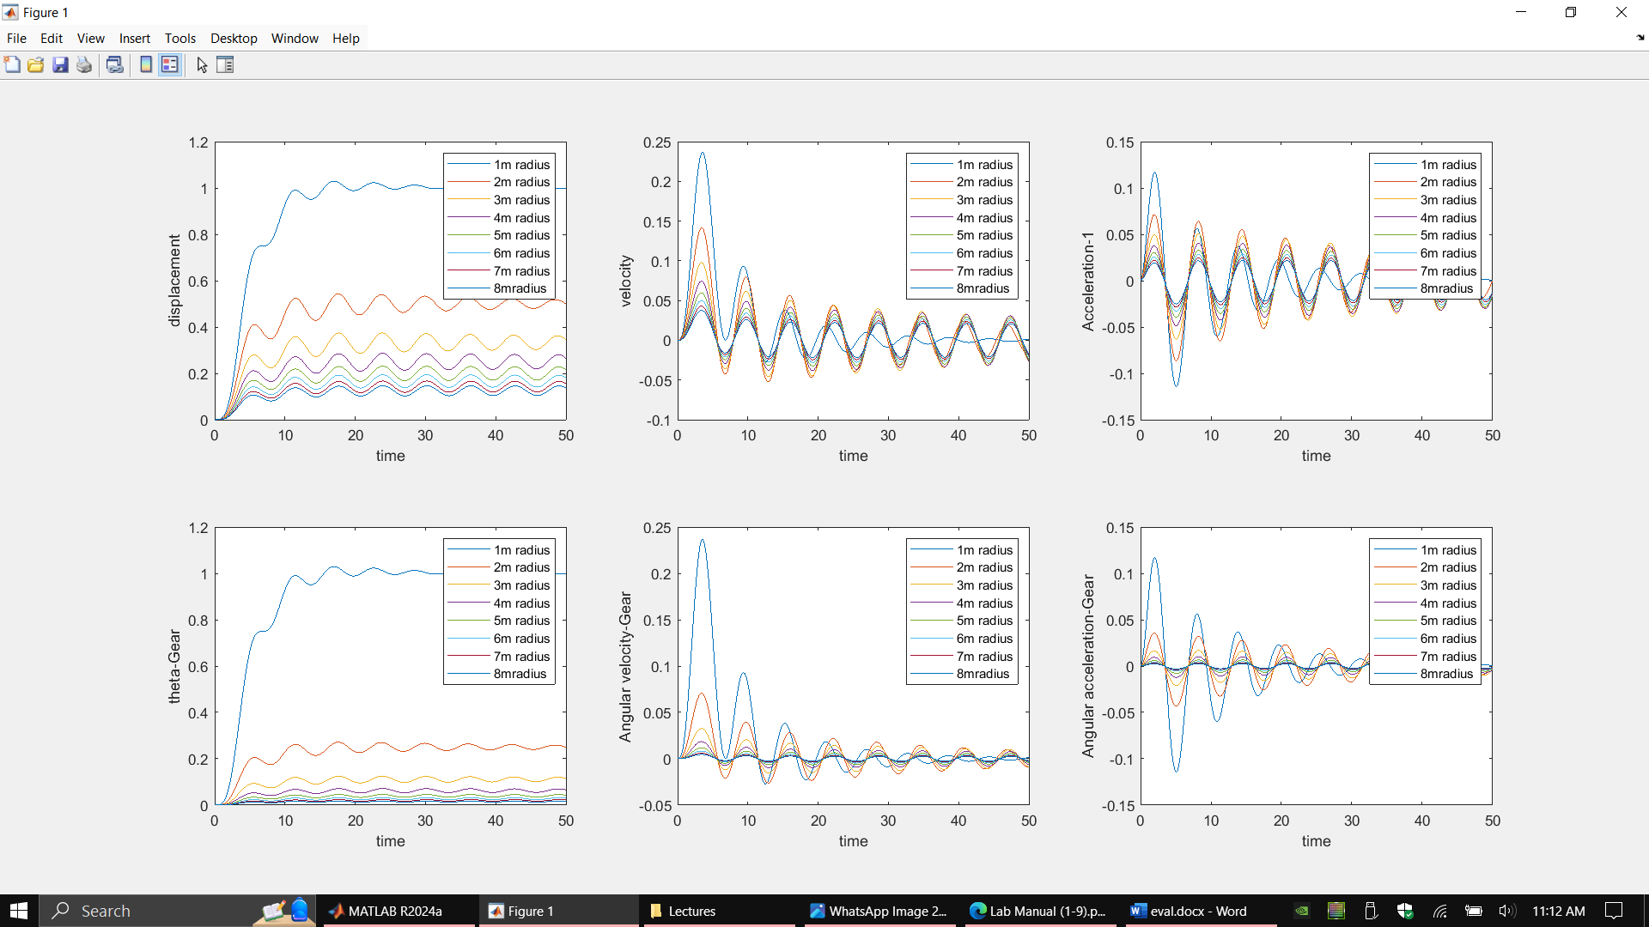

Fvs---------------------------------------------------------------------------------

clc;

clear;

TR = [0 50];

X0 = [0;0;0;0;0;0];

k1=8;k2=5;fv=25;d3=2;T=5;m=15;J1=8;J2=10;J3=12;r=5;

for fv=10:5:40

[t,y]=ode45(@(t,y)randFun(t,y,T,J1,J2,J3,m,r,fv,k1,k2,d3),TR,X0);

thGear=y(:,3);

omGear=y(:,4);

x=r*thGear;

v=r*omGear;

% Compute acceleration

a1 = gradient(v, t);

a2 = gradient(omGear, t);

subplot(2,3,4)

plot(t,thGear)

hold on

xlabel('time')

ylabel('theta-Gear')

subplot(2,3,5)

plot(t,omGear)

hold on

xlabel('time')

ylabel('Angular velocity-Gear')

subplot(2,3,1)

plot(t,x)

hold on

xlabel('time')

ylabel('displacement')

subplot(2,3,2)

plot(t,v)

hold on

xlabel('time')

ylabel('velocity')

subplot(2,3,3)

plot(t, a1)

hold on

xlabel('time')

ylabel('Acceleration-1')

subplot(2,3,6)

plot(t, a2)

hold on

xlabel('time')

ylabel('Angular acceleration-Gear')

end

for i=1:6

subplot(2,3,i);legend('fv 10', 'fv 15', 'fv 20','fv 20', 'fv 25', 'fv 30', 'fv 35', 'fv 40')

end

